Dear Censor Board and relevant authorities,

The blockbuster film, The Kashmir Files, due for release on New Zealand screens 24th March 2022 was withdrawn last week by the NZ Censor Board for further classification and review after complaints from Muslim groups.
In over 1 billion screenings there has not been a single hate crime committed by Hindus against Muslims as alleged in the complaints.
Neither an explanation was offered by the Censor Board, nor even a notice. The film was withdrawn ad hoc without community consultation. It did not request views of: Kashmir Pandits diaspora (who are the victims shown in this movie), Hindu community, the wider community, or Kashmiri Muslim dissidents who support the film and are brave enough to stand up to the terrorism inside Kashmir and are witness to Kashmir Pandit massacres -- see (Beigh, 2022).
Instead, the Censor Board took opinions of people who have taken ownership without consultation, of how Hindu stories are told, and how Islamist terrorism is portrayed to New Zealand citizens and how Muslims should think about the film despite none of their community having watched it.

Danger of not screening the film
The arguments against the film tacitly condone terrorism in Kashmir by negating responsibility of separatist terror groups, attempting to shut down and silence minorities targeted by terrorists and to rewrite the history of Kashmir sanitised of the violent impact of terrorism on the valley, this time since 1931.
The complainants further endorse views of separatist terrorists depicted in the film by their Hinduphobic stereotypes that repeat talking points of Kashmiri separatist terrorists.
Last December terrorists targeted and killed Hindus, a Sikh and a Muslim over allegations they had connections to ‘Hindutva’ causing 3000 government workers to leave the valley in fear.
The complaints are unsubstantiated. We submit our response point by point.

Complaints
- ‘Muslims in NZ’ Facebook group
This group called members to send emails from their template.
Allegations raised in the post (numbered) and our response (lettered):
- Claim: The movie is ‘Islamophobic’, violent and graphic.

  - Graphic violence is covered by appropriate classification and R16 was approved.
  - A definition of Islamophobia cannot be accepted that bans recognition or portrayal of graphic violence and terrorism for fear of harming ‘Muslim’ sentiments. (UN, 2022)

- Claim: The movie is ‘supported by Hindutva elements’.

  - Terrorists in Kashmir continue to attack civilians on the basis of alleged loyalty to either ‘Hindutva or the Indian State’.
  - The argument repeats terrorist propaganda.
  - Hindus of NZ have been vilified by scholars and activists in New Zealand as ‘terrorists’ using the terms Hindutva and VHP suggesting they are a security risk to NZ and Australia which is by definition Hinduphobia. (OUP, 2021)

- Claim: It is ‘to raise anti-Muslims and anti-Kashmiri sentiments’.

  - Hindus of Kashmir ARE the aboriginal culture and community of Kashmir for 5000+ years. The film documents ‘anti-Kashmiri’ and ‘anti-Hindu’ sentiment.
  - We reject that portrayal of anti-Hindu violence equates to raising ‘anti-Muslim violence’.
  - Both Kashmiri Muslims and Kashmir Hindus are the victims of Islamist terrorism in the valley and whilst this film portrays scenes leading to Hindu ethnic cleansing, it should not be accepted that a failure to tell the story of Muslim victims is automatically anti-Muslim. Muslims of Kashmir are depicted in every news article on Kashmir while Hindu voices have not been heard to date and they have a right to justice.
  - The film tells the true story of victims on behalf of survivors who are still today in exile and approve of the film by consensus. Their story, however hurtful, must be told. We do not restrict historic accounts of British colonialism to protect the feelings of people who might look like them. That would negate and silence the victims.

- Claim: The movie is controversial.

  - This is not true and is not even a sufficient reason to ban the movie. The movie is based on documented real events the research for which was done for 2.5 to 3 years.

- Claim: As a ‘concerned citizen and Muslim I am worried that there [a] could be a rise in Islamophobia and hate toward Muslims in Aotearoa [b] by the NZ Hindutva groups which is [c] already seen in India’. (Letter template)

  - No evidence is provided as to why Muslims should veto a film about Hindu victims of Islamist terrorism, nor how this film would cause hatred toward a community that are not part of or responsible for the events.
  - It stereotypes and accuses New Zealand Hindus of hatred toward Muslims. The complaint demonstrates Hinduphobia:

    - It muzzles Hindu freedom of expression and FOE in general.
    - Anti Hindu violence is silenced.
    - Members of the victim class are accused of ‘pre-crime’ attacks against Muslims who ‘fear’ them – irrationally aka ‘phobia’.
    - It is the Muslim groups conflating Kashmiri terrorists with Muslims, arguing that depiction of terrorism is Islamophobic – not Hindus.

- The Federation of Islamic Associations of New Zealand
A letter from The Federation of Islamic Associations of New Zealand dated 18 March 2022 makes similar accusations:
- Claim: The Kashmir Files has resulted in serious and widespread anti-Muslim and anti-Kashmir sentiments in India.

  - No evidence is provided for this claim. Over 1 billion people have watched this movie across different continents USA, Europe, India and Australia and there has not been any, NOT EVEN ONE, incident of this nature.
- Claim: The film is ‘promoted globally by Hindu Right Wing groups such as RSS and VHP both overseas and in Aotearoa.

  - The film is distributed by Zee Films and I Am Buddha, neither of whom are political organisations. They are not ‘RSS’ or ‘VHP’ either.
  - AFICNZ do not state why it is problematic for NZ VHP or other Hindus to promote a film.

- Claim: ‘The film is promoting widespread hate and social discord in India’.

  - This claim is not substantiated.

- Claim: Gregory Stanton of Genocide Watch has issued a ‘genocide alert for Kashmir’.

  - The Genocide Watch alert accepts the basis of claims made in the movie (Genocide-Watch, 2019):

    - “In 1984, Kashmiri Muslim youth began demonstrations for Kashmiri indigenous self-determination that were crushed by Indian armed forces. Riots destroyed Hindu properties in 1986; armed Muslim insurgents targeted Hindus in 1989; and in 1990, over 100,000 Hindu pandits fled from Kashmir.”

  - The ‘alert’ refers to a 1947 UN document and evades the more recent UN Simla agreement, failing to address the decades long invasion of India by Pakistan and that the condition of any plebiscite was the withdrawal of Pakistan troops from Indian International territory. (Gandhi & Bhutto, 1972)

  - The film is about Kashmir Pandit ethnic cleansing not about Muslims and has nothing to do with the claims made of Gregory Stanton, a lobbyist who appears on pro-Kashmiri separatist panels regularly and whose impartiality to the terrorist agenda is dubious.

- Claim: ‘A fictitious genocide of Kashmir Pandits is to make genocide of Muslims in the future acceptable and necessary’.

  - The source referred to by AFICNZ of Stanton supports the fictionalised events based on true stories.
  - In 700 years a fully indigenous Hindu state has been reduced to 1% of the population and the attacks have not stopped. This is, by definition, a genocide – even applying Stanton’s 10 stages. Hindus are in the final stage.
  - It is highly offensive to claim Hindu victims of ethnic cleansing in 1990 and over 700 years, by the destruction of their genes, should stand accused, a trial by Censor Board, of making up their experience so that they can render genocide acceptable against Muslims. This is Hinduphobia.
  - The movie is based on documented real events, the research for which has been done for 2.5 to 3 years.

- Claim: Evidence of ‘CJ Werlemen’.

  - CJ Werleman is a hostile anti-Hindu and anti Semitic lobbyist in the USA with no academic credibility who still profits from Islamophobic books.

- Claim: A video of a man after a film screening ‘calls for Hindu men to abduct, marry and impregnate Muslim women so that Hindu babies can be harvested from Muslim wombs.’

  - This is not what the video says.
  - Nobody in the audience aside from the person, filming from the moment he stands up, knows who he is.
  - Hindus of NZ should not pay by censorship for the actions of 1/1.1billion people. There is more chance of being eaten by a shark and still the beaches are open.

- Claim: This is ‘one example of an alarming trend’.

  - No other examples are given from 1.1 billion viewers.

- Claim: [Therefore] ‘the film will cause further social discord in Aotearoa…fuel Islamophobic hate…disrupt all our efforts to create a cohesive society’.

  - On what basis does any of this have to do with New Zealand citizens attacking New Zealand Muslims?

- Claim: March 15 a man killed 52 Muslims [Christchurch Mosque attacks].

  - This has nothing to do with the film.

- Claim: Screening the film shows insensitivity to the feelings of Muslims in New Zealand.

  - If Muslims in New Zealand do not want Islamist terrorism on their screens because it hurts their feelings and want to prevent the entire country viewing it to protect them from white supremacists, there should be evidence from Australia, Germany, the UK, America and other western countries demonstrating a Christchurch like scenario.

  - The only argument is that one unknown Indian yelled after a screening.

  - Showing Islamist terrorism cannot be rightfully accepted as Islamophobia because, as we are all very well aware, Muslims and Islam are not to be associated with Islamist extremists.

We submit herewith a letter with 2000 signatures.

Sincerely,

Global Kashmir Pandit Diaspora Australia (GKPD)
Kashmir Pandits Australia (KPA)
Hindu Human Rights Australia (HHR)
Australian Hindu Association (AHA)
Hindu Council of Australia (HCA)

Contacts: Ash Raina (GKPD) Brisbane II +61 403 208 908 II ashutosh.raina@gmail.com II
Sarah L Gates (HHR) II +61 478 602 772 II contact@hinduhumanrights.com.au II
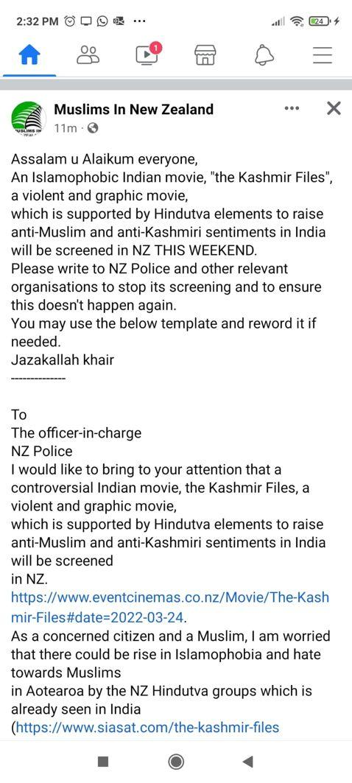
Annexure A
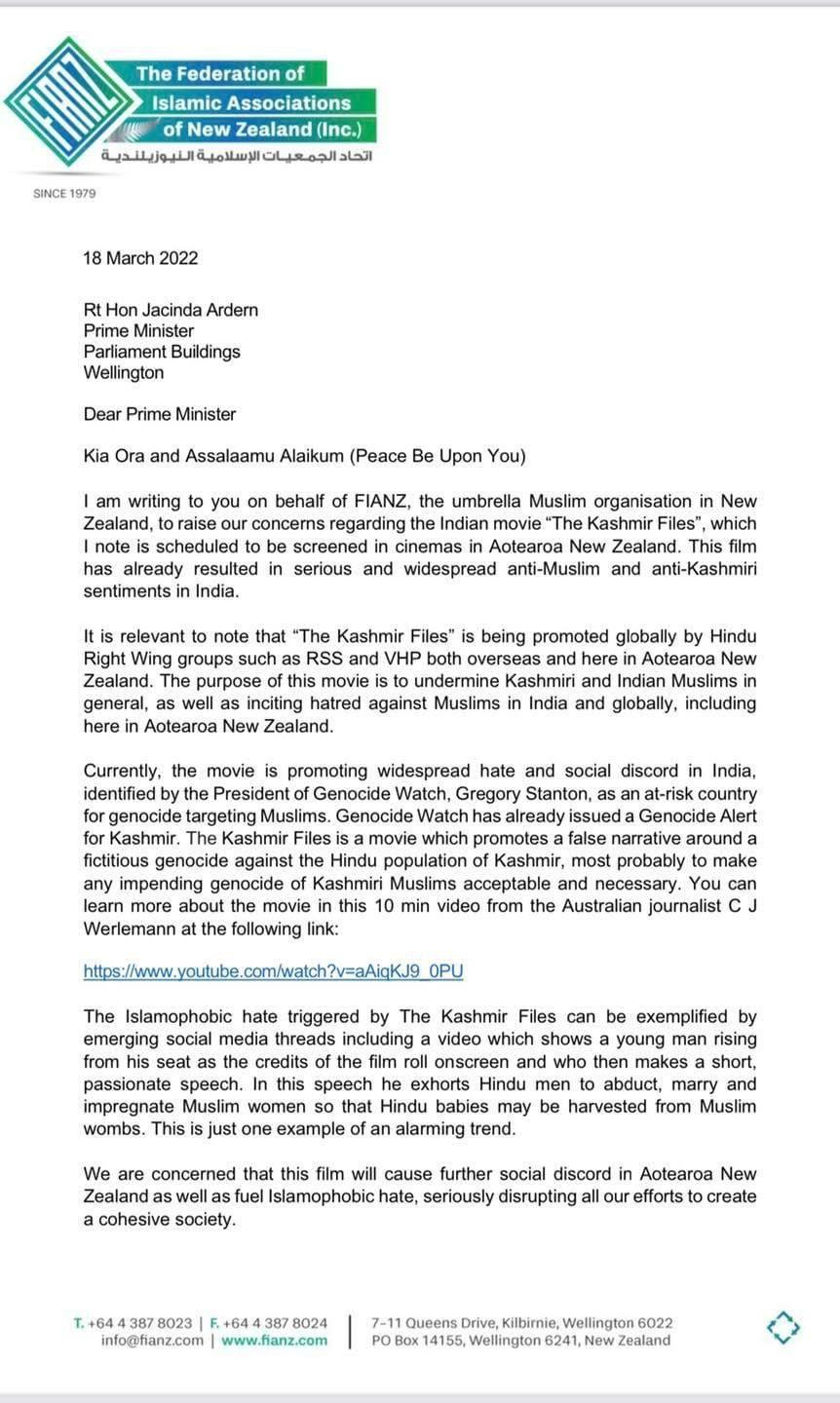
Annexure B p.1
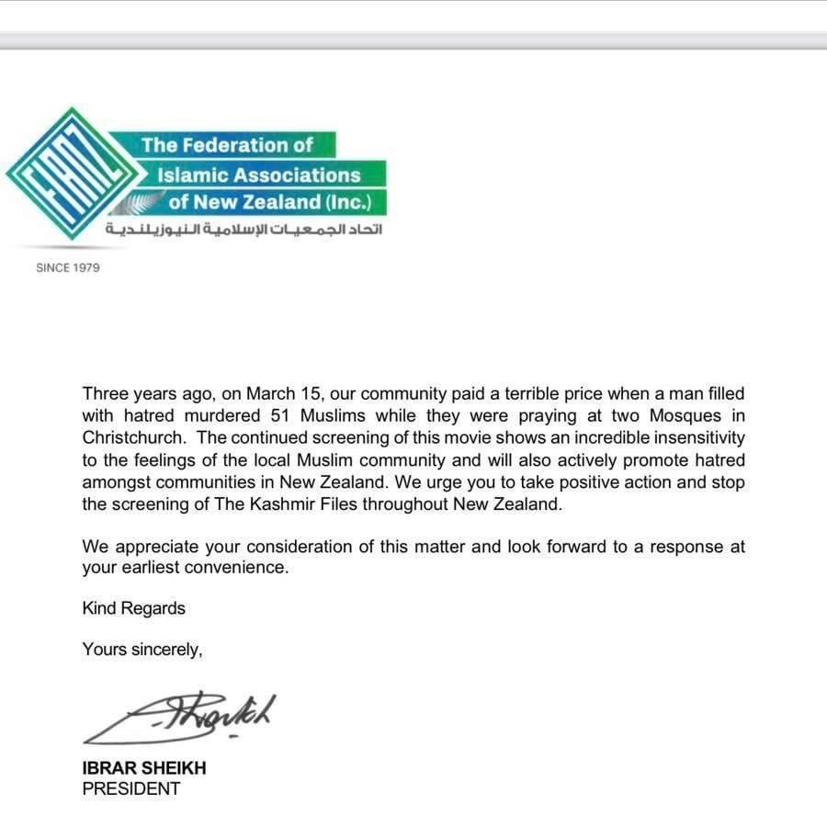
Annexure B p.2

Annexure C
Allegations of Genocide of majority Muslims in Kashmir are not founded on population growth or demographic data and should not be used to stifle discourse on ethnic cleansing of Hindus.
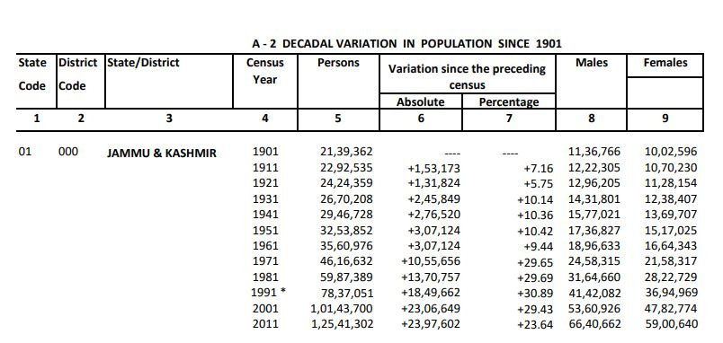
https://www.censusindia.gov.in/2011census/PCA/A-2_Data_Tables/01%20A-2%20J%20&%20K.pdf
Useful charts are found here: https://indianexpress.com/article/explained/share-of-muslims-and-hindus-in-jk-population-same-in-1961-2011-censuses/

South Asia Terror Portal civilian deaths are due to ongoing terrorism, not ‘Hindus’ or the Governments (SATP, 2022)

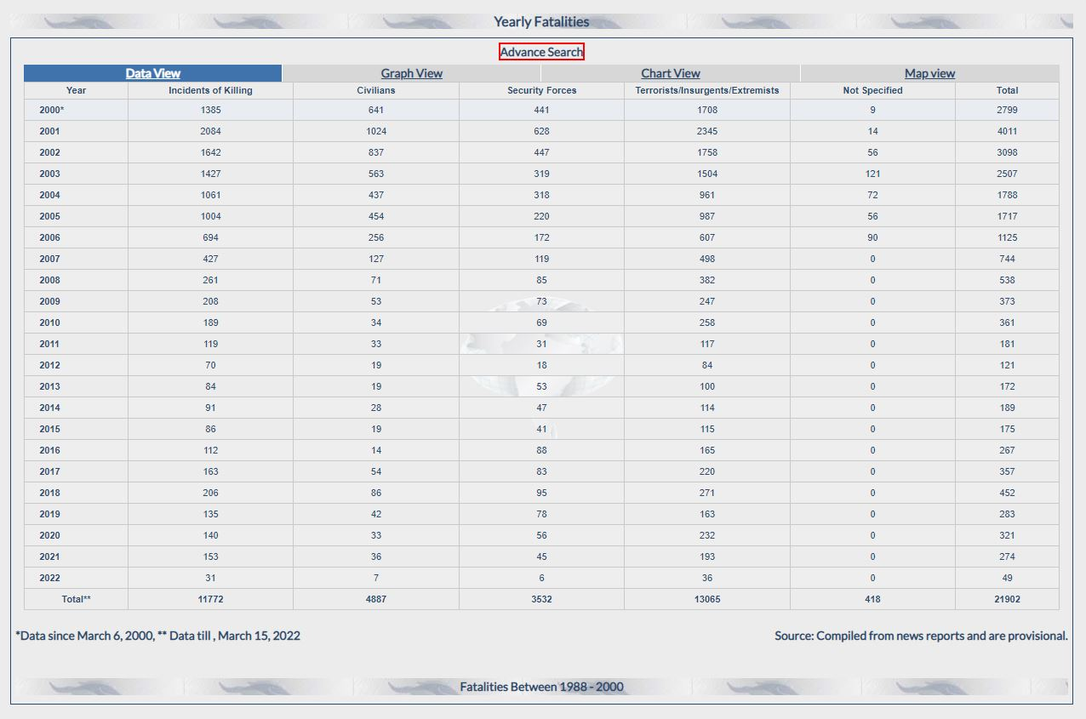

Annexure D
Twitter video circulated on social media made by unknown persons unrelated to crowd. This gets no support from the audience, and they are clearly embarrassed by the outpouring.
Link to video uploaded privately to YouTube here: https://youtu.be/OWrMYyyyJXQ
Claim of AFICNZ:
“Calls for Hindu men to abduct, marry and impregnate Muslim women so that Hindu babies can be harvested from Muslim wombs.”
Literal translation:
“If our young boys, aged 20 or 25 start marrying Muslim girls, then in three generations their population will be less. Marry their girls and bear less kids. We are watching here, and they are busy in their homes putting more of them into the world.”

References
Beigh, J. (2022, March 18). https://twitter.com/Javedbeigh. Retrieved from https://twitter.com/Javedbeigh/status/1504732785675702273?s=20&t=NS6rqxQnYmGTiXNCvnXsLw
Gandhi, I., & Bhutto, Z. A. (1972, July 2). Simla Agreement. Retrieved from https://mea.gov.in/in-focus-article.htm?19005/Simla+Agreement+July+2+1972
Genocide-Watch. (2019, March). Alerts: Kashmir. Retrieved from https://www.genocidewatch.com/copy-of-current-genocide-watch-aler
OUP, O. U. (2021). Hinduphobia. Lexico Online Dictionary. Retrieved from https://www.lexico.com/definition/hinduphobia
SATP, S. A. (2022, March). Jammu and Kashmir Datasheet. Retrieved from https://satp.org/datasheet-terrorist-attack/fatalities/india-jammukashmir

Annexure A
Annexure B
Annexure C
Annexure D with verbatim translation By Ash Raina of Global Kashmir Pandit Diaspora

